The Board we are going to use:

https://www.aliexpress.com/item/Wemos-ESP8266preflashed-development-board-OLED-version-ESP8266-18650-OLED/32819513410.html?spm=a2g0s.9042311.0.0.3da24c4dJDfL18

Esp8266 Motherboard ESP8266 Mini-WiFi NodeMCU Module
18650 holder
Battery OLED
Model:ESP-8266
Color:Black
Charging Protection:Yes
Discharge Protection:Yes
Compatible With NodeMCU
Wide Voltage Input Range: 5V~12V
Charge Current:500 mA
Size(L*W*H):102 x 30 x 20 mm
Display Size: 0.96 In

Features:
1.One AD (Analog to Digital) inputs.
2.Micro USB inputs.
3.One programmable LED (D0 = GPIO16).
4.Integrated 18650 battery charging and discharging system.
5.One switch controls whether the 18650 battery is powered or not.
6.OLED's SDA and SCL connect to the D1 pin and the D2 pin respectively.
7.The five buttons are controlled by FLASH, RSET, D5, D6, and D7 respectively.
8.The 5 Digital pins can configure the write/read/interrupt/pwm/I2C/one-wire supported separately.
9.Operation and NodeMCU consistent, adding a programmable LED, you can use GPIO16 to control, display 8266 running status and other functions. Integrated OLED (SSD1306 chip) and five button, more convenient for development.
10.The design concept originates from the open source project NodeMCU,
and the development board integrates 18650 charging and discharging systems with charging and discharging protection.
At the same time, a OLED and five directional buttons are integrated to facilitate the development.
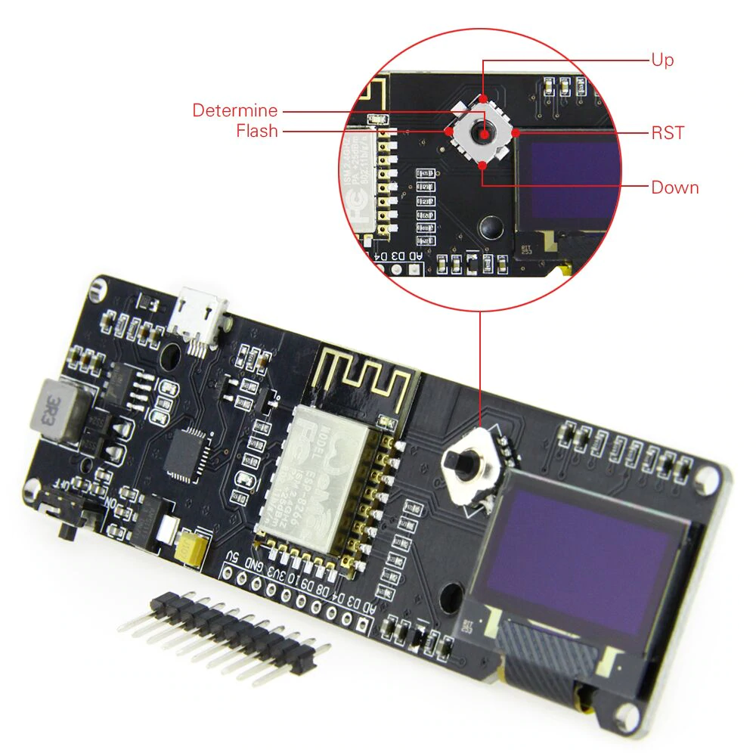
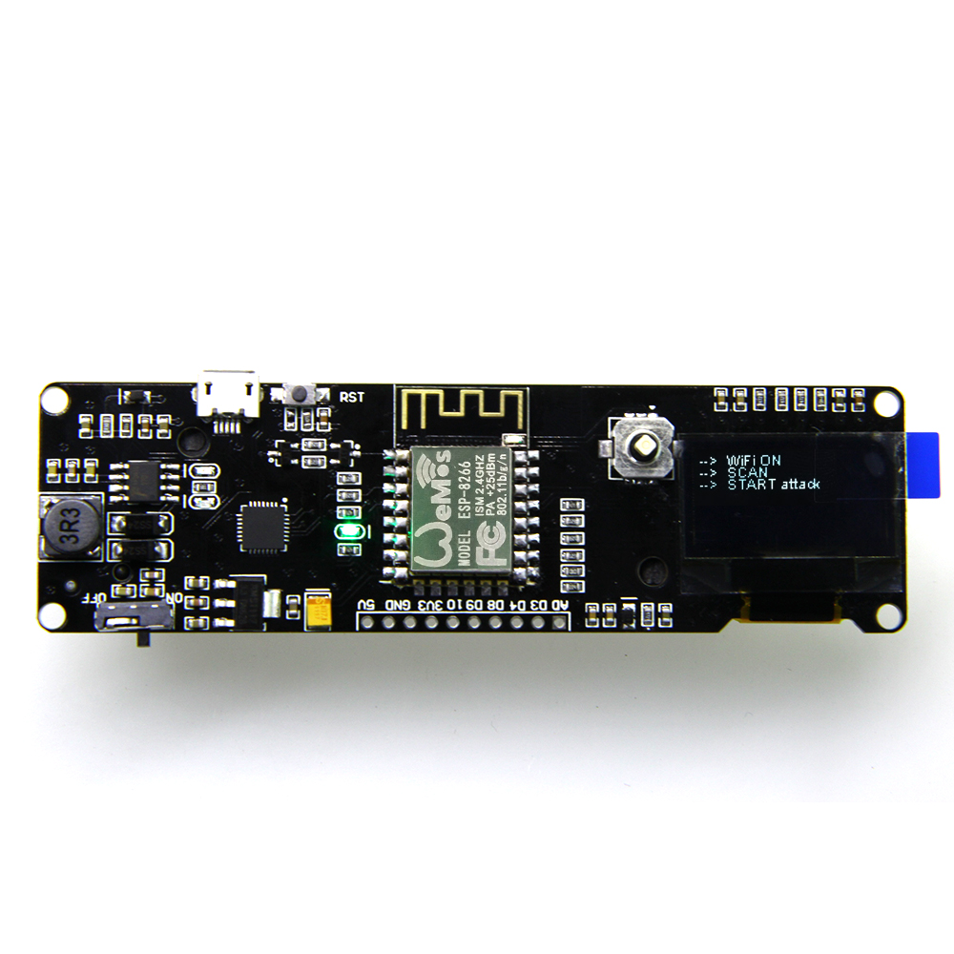
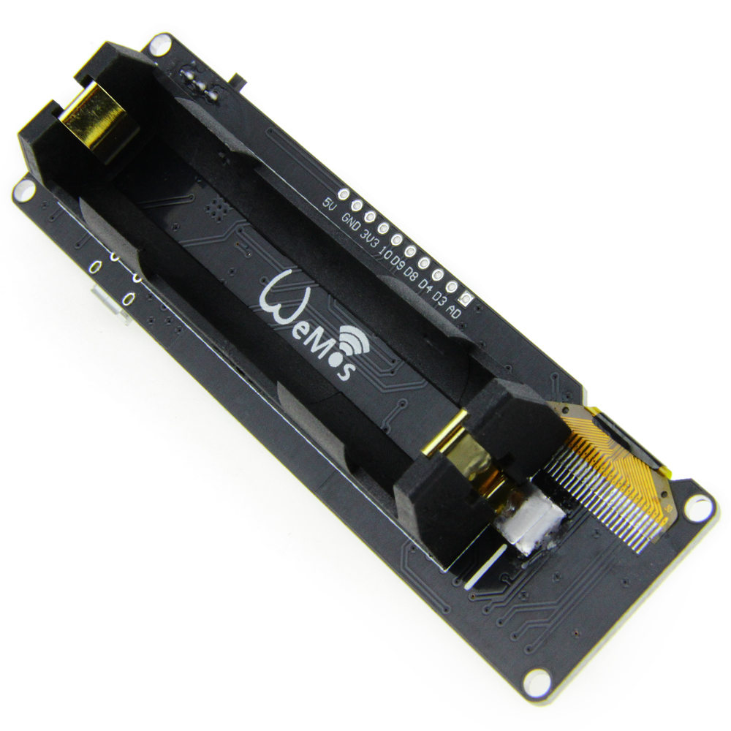
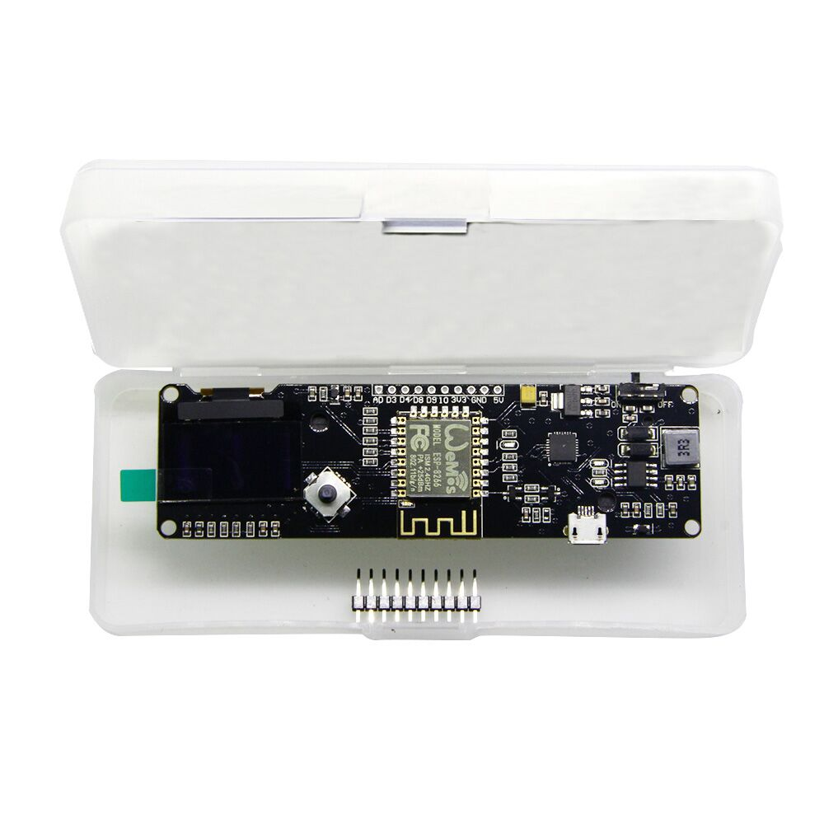

Dimension drawings (manual measurements, with some 1-3MM errors):
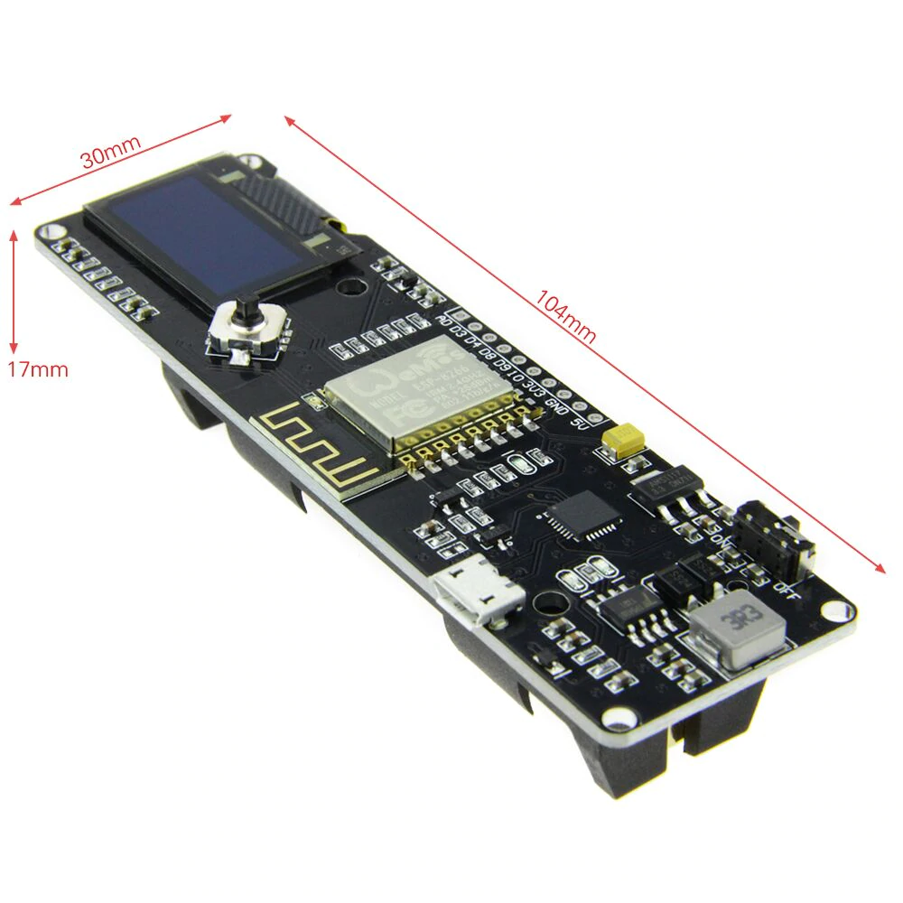

Pin Names on NodeMCU Development Kit | ESP8266 Internal GPIO Pin number
D0 | GPIO16
D1 | GPIO5
D2 | GPIO4
D3 | GPIO0
D4 | GPIO2
D5 | GPIO14
D6 | GPIO12
D7 | GPIO13
D8 | GPIO15
D9/RX | GPIO3
D10/TX | GPIO1
D11/SD2 | GPIO9
D12/SD3 | GPIO10

